This dataset consists of two columns i,e., first_name & last_name &city use custom input format to read the key as the combination of first_name and last_name and arrange the output of the program should be the key sorted by last_name

Driver class:

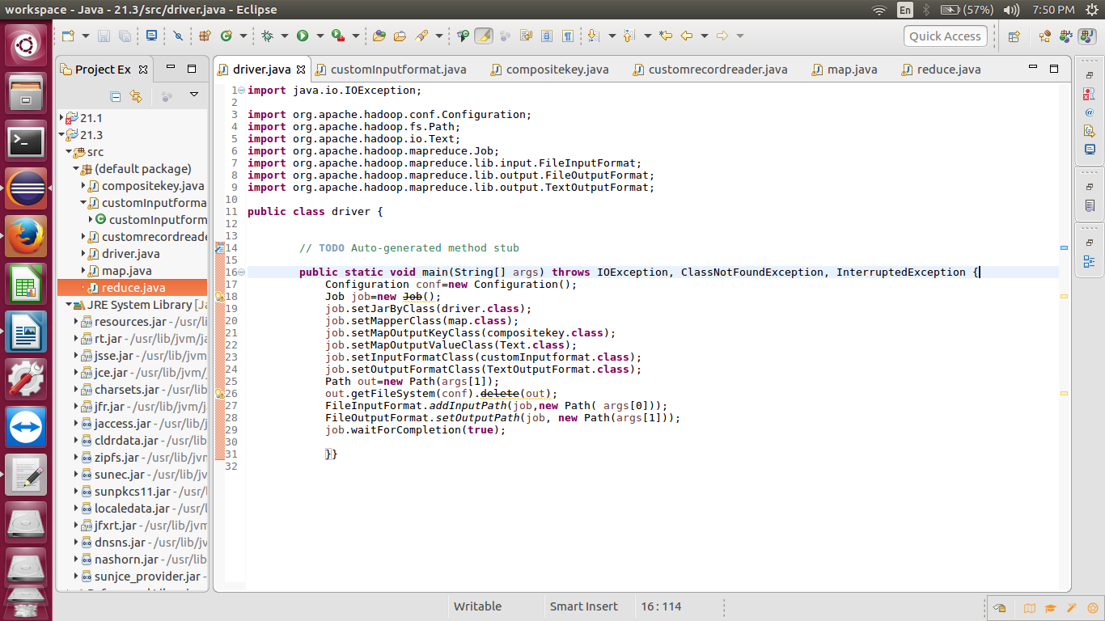

Fileinputformat class:



Writable comparator class:

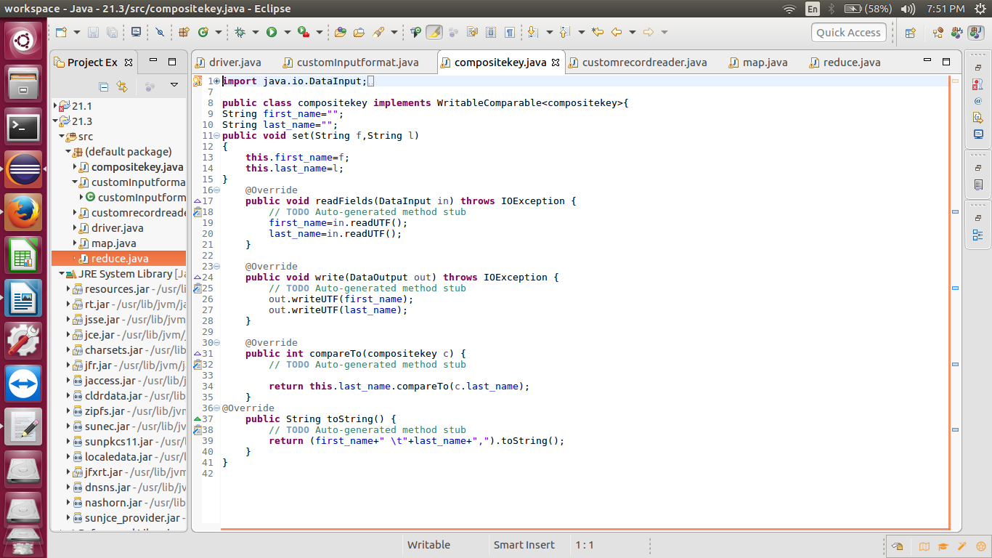

RecordReader class:

Mapper class:

Reducer class:

Running jar:

Output: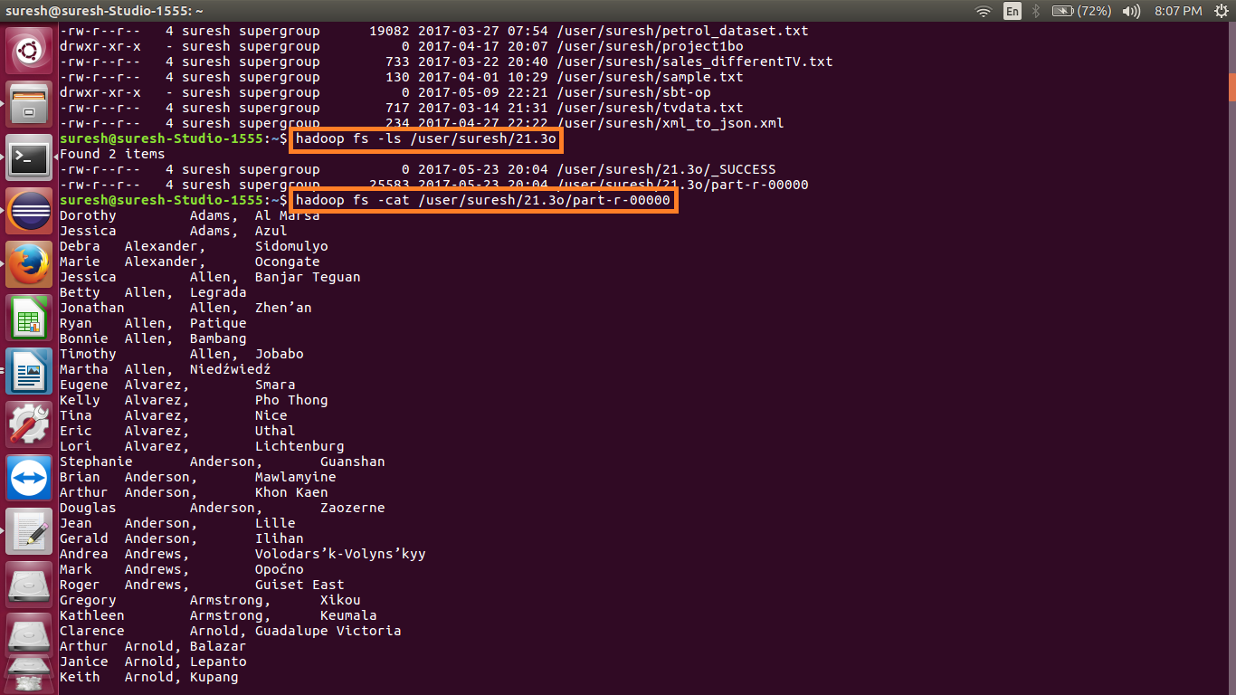

|  |
| --- |
| Dorothy Adams, Al Marsá |
|  | Jessica Adams, Azul |
|  | Debra Alexander, Sidomulyo |
|  | Marie Alexander, Ocongate |
|  | Jessica Allen, Banjar Teguan |
|  | Betty Allen, Legrada |
|  | Jonathan Allen, Zhen’an |
|  | Ryan Allen, Patique |
|  | Bonnie Allen, Bambang |
|  | Timothy Allen, Jobabo |
|  | Martha Allen, Niedźwiedź |
|  | Eugene Alvarez, Smara |
|  | Kelly Alvarez, Pho Thong |
|  | Tina Alvarez, Nice |
|  | Eric Alvarez, Uthal |
|  | Lori Alvarez, Lichtenburg |
|  | Stephanie Anderson, Guanshan |
|  | Brian Anderson, Mawlamyine |
|  | Arthur Anderson, Khon Kaen |
|  | Douglas Anderson, Zaozerne |
|  | Jean Anderson, Lille |
|  | Gerald Anderson, Ilihan |
|  | Andrea Andrews, Volodars’k-Volyns’kyy |
|  | Mark Andrews, Opočno |
|  | Roger Andrews, Guiset East |
|  | Gregory Armstrong, Xikou |
|  | Kathleen Armstrong, Keumala |
|  | Clarence Arnold, Guadalupe Victoria |
|  | Arthur Arnold, Balazar |
|  | Janice Arnold, Lepanto |
|  | Keith Arnold, Kupang |
|  | Alice Arnold, Nova Viçosa |
|  | Sarah Arnold, Phùng |
|  | Martin Austin, Den Chai |
|  | Martha Austin, Yoichi |
|  | Sandra Austin, Bulualto |
|  | Teresa Austin, Pho Si Suwan |
|  | Amy Bailey, Pagak Kulon |
|  | Stephanie Bailey, Cherepovets |
|  | Ruth Bailey, Grand Bank |
|  | Timothy Bailey, Tazemmourt |
|  | Scott Baker, Ferreira |
|  | Aaron Baker, Baini |
|  | Gerald Banks, Npongge |
|  | Kenneth Banks, Xiapu |
|  | Clarence Banks, Cergy-Pontoise |
|  | Bonnie Banks, Gandu |
|  | Paula Banks, Ponte da Pedra |
|  | Mark Barnes, Klippan |
|  | Scott Barnes, Banaba |
|  | Timothy Barnes, Sabanagrande |
|  | Jean Barnes, Angoulême |
|  | Bonnie Barnes, Sasnovy Bor |
|  | Joyce Barnes, Paris 02 |
|  | Shawn Bell, Svetlyy |
|  | Bobby Bell, Tataouine |
|  | Eugene Bell, Norfolk |
|  | Adam Bell, Jifarong |
|  | Christina Bell, Vila Moreira |
|  | Andrea Bell, Tayuan |
|  | Linda Bennett, Toyoshina |
|  | Phyllis Bennett, Sentul |
|  | Tammy Bennett, Suhopolje |
|  | Gloria Berry, Tarauacá |
|  | Steve Berry, Bokor |
|  | Deborah Berry, Shajing |
|  | Janet Berry, Andou |
|  | David Bishop, Semerak |
|  | Maria Bishop, Ridder |
|  | Heather Bishop, Tandag |
|  | Martin Black, Kisovec |
|  | Johnny Black, Milton |
|  | Adam Black, Nyzhni Petrivtsi |
|  | Maria Black, Melaka |
|  | Jose Black, Białośliwie |
|  | Adam Black, Dongping |
|  | Pamela Black, Józefosław |
|  | Jose Bowman, Redon |
|  | Timothy Bowman, Quetta |
|  | Diane Boyd, Černožice |
|  | Ryan Boyd, Cibatu |
|  | Roy Boyd, Borek Wielkopolski |
|  | Craig Bradley, Chongkan |
|  | Randy Brooks, Songjiang |
|  | Joshua Brown, Mocoa |
|  | Mark Brown, Shuangjiang |
|  | Ralph Brown, N'Djamena |
|  | Matthew Brown, Apartadó |
|  | Alice Brown, Quichuay |
|  | Frank Bryant, Jianzhatan |
|  | Roger Bryant, Szeged |
|  | Brian Bryant, Cruces de Anorí |
|  | Marilyn Burke, Vimieiro |
|  | Thomas Burke, Millau |
|  | Anthony Burke, Yangjia |
|  | Donna Burke, Lao Suea Kok |
|  | Jennifer Burke, Lidköping |
|  | Judith Burns, Preobrazhenka |
|  | Kathy Burns, Illapel |
|  | Samuel Burns, Paringin |
|  | Lisa Burton, Phoenix |
|  | Christina Butler, Cachoeirinha |
|  | Frances Butler, Hufang |
|  | Keith Butler, Tempuran |
|  | Walter Butler, Bandar Seri Begawan |
|  | Elizabeth Butler, Limeira |
|  | Mildred Butler, Longjing |
|  | Lillian Butler, Donnybrook |
|  | Phyllis Campbell, Urpay |
|  | Jose Campbell, Polje |
|  | Gloria Campbell, Yinhedahan’er |
|  | Stephen Campbell, Boavista |
|  | Mary Campbell, Uttar Char Fasson |
|  | Janice Carpenter, Dvůr Králové nad Labem |
|  | Eugene Carpenter, Blumenau |
|  | Howard Carpenter, Shapaja |
|  | Linda Carpenter, Iperó |
|  | Eric Carroll, Kota Kinabalu |
|  | Arthur Carroll, Oskarshamn |
|  | Shirley Carroll, Tegalagung |
|  | Theresa Carroll, Gomel |
|  | Louis Carroll, Zamora |
|  | Ernest Carroll, Västra Frölunda |
|  | Daniel Carroll, Benito Juarez |
|  | Carl Carter, Kurume |
|  | Johnny Carter, Nebug |
|  | Andrea Carter, Hödrögö |
|  | Donna Carter, Acolla |
|  | Louis Castillo, Besançon |
|  | Donna Castillo, Ningxi |
|  | Patricia Castillo, Pop Shahri |
|  | Ernest Castillo, Cortes |
|  | Michael Castillo, Guocun |
|  | Lois Chapman, Mirsíni |
|  | Brenda Chapman, Sepīdān |
|  | George Chapman, Chumphon Buri |
|  | Donna Chapman, Calais |
|  | Robin Chapman, Cilebang Satu |
|  | Janice Chavez, Zavolzh’ye |
|  | Joyce Chavez, João Câmara |
|  | Patrick Chavez, Zaña |
|  | Rose Chavez, Kożuchów |
|  | Kelly Chavez, Jōetsu |
|  | Kenneth Clark, Pendembu |
|  | Gloria Clark, Pacho |
|  | George Clark, Voloshka |
|  | Kelly Clark, Ḩawsh ‘Īsá |
|  | Christopher Clark, Farriar |
|  | Melissa Clark, Thanh Nê |
|  | Heather Clark, Santo André |
|  | Irene Clark, Tiebukenwusan |
|  | Judy Clark, Gandusari |
|  | Jeffrey Clark, Tubajon |
|  | Matthew Cole, Kalinovo |
|  | Martin Cole, Ussel |
|  | Ann Cole, Pulian |
|  | Martha Cole, Médanos |
|  | Andrew Cole, Nova Viçosa |
|  | Wanda Coleman, Gwoźnica Górna |
|  | Ann Coleman, Zhuxi |
|  | Raymond Coleman, Jindayris |
|  | Timothy Collins, Whitchurch |
|  | Ruth Collins, Pridraga |
|  | Richard Collins, Libertad |
|  | Raymond Cook, Guanmian |
|  | Wayne Cook, Aioi |
|  | Diana Cooper, Bonn |
|  | Barbara Cooper, Yabuli |
|  | John Cooper, Ðà Lạt |
|  | Todd Cooper, Huinca Renancó |
|  | Jimmy Cooper, Boshi |
|  | Angela Cooper, Gakovo |
|  | Alan Cox, Xinzheng |
|  | Henry Cox, Santa Maria |
|  | Lois Crawford, Mogok |
|  | Maria Crawford, Grand Junction |
|  | Jeffrey Crawford, Obas |
|  | Nicholas Crawford, Wailolong |
|  | Gregory Cruz, Pachīr wa Āgām |
|  | Steve Cruz, Złotów |
|  | Willie Cruz, Zbůch |
|  | Walter Cruz, Vilhena |
|  | Ryan Cruz, Úštěk |
|  | Lawrence Cruz, Mouriscas |
|  | Elizabeth Cunningham, Tigbao |
|  | Lisa Daniels, Pingdong |
|  | Sharon Daniels, Dabaozi |
|  | Kathleen Daniels, Mandapajaya |
|  | Andrew Daniels, Banyo |
|  | Phillip Daniels, Hongqi |
|  | Ann Daniels, Valencia |
|  | Anna Davis, Diavatá |
|  | William Davis, Salavat |
|  | Brenda Davis, Luzhou |
|  | Kathy Day, Orleans |
|  | Ronald Day, Petřvald |
|  | Matthew Day, Heshan |
|  | Stephanie Day, Ejigbo |
|  | Alice Dean, Boulogne-Billancourt |
|  | Joan Dean, Vila Nova Sintra |
|  | Joseph Diaz, Dahua |
|  | Paul Diaz, Albuquerque |
|  | Amy Diaz, Krynychky |
|  | Donna Diaz, Tsil’na |
|  | Larry Diaz, Ulundi |
|  | Maria Dixon, La Concepcion |
|  | Walter Dixon, Ílion |
|  | Teresa Dixon, Williston |
|  | Rachel Dixon, Huangtian |
|  | Steve Dixon, Norabats’ |
|  | Chris Dixon, Oliveira |
|  | Matthew Dixon, Alikalia |
|  | Kelly Dixon, Qādirpur Rān |
|  | Robin Duncan, Nangahale |
|  | Sean Duncan, Luxor |
|  | Craig Duncan, Satuek |
|  | James Dunn, El Corozo |
|  | Henry Dunn, Acopampa |
|  | Paula Dunn, Gondang |
|  | Jeffrey Dunn, Cruz |
|  | Rose Edwards, Tenri |
|  | Brandon Edwards, Yanhe |
|  | Patrick Edwards, Arbuzynka |
|  | Matthew Elliott, Mora |
|  | Patricia Elliott, Lindome |
|  | Virginia Elliott, Alīpur |
|  | Carolyn Ellis, Sumberan |
|  | Ann Ellis, Fuling |
|  | Lillian Ellis, Banjeru |
|  | Alan Ellis, Bogoria |
|  | Joseph Evans, Tsimasham |
|  | Jason Evans, Ängelholm |
|  | Gloria Evans, Ichinomiya |
|  | Dorothy Evans, Bromma |
|  | Betty Evans, Dziadkowice |
|  | Mildred Evans, Huaicheng |
|  | Walter Ferguson, Gondomar |
|  | Carolyn Fernandez, Jianghai |
|  | Bonnie Fernandez, Jadowniki |
|  | Martha Fields, Notre-Dame-de-l'Île-Perrot |
|  | Joe Fields, Muleng |
|  | Roger Fields, Agía Paraskeví |
|  | Kimberly Fields, Miguelópolis |
|  | Diana Fields, Bununu Kasa |
|  | Brian Fields, Vuzenica |
|  | Ronald Fields, San Jose |
|  | Ann Fisher, Извор |
|  | Anna Fisher, Shengao |
|  | Fred Flores, Seren Barat |
|  | Ryan Flores, Haninge |
|  | Harry Flores, Chocope |
|  | Jessica Flores, Ash Shāmīyah |
|  | Michael Flores, Nouakchott |
|  | Jesse Flores, Stockholm |
|  | Ruth Flores, Maple Ridge |
|  | Jose Ford, Itaberaba |
|  | Helen Ford, Tivat |
|  | Donna Ford, Gorzyczki |
|  | Sharon Ford, ‘Abasān al Kabīrah |
|  | Laura Ford, Tanjungkerta |
|  | Eugene Foster, Nijmegen |
|  | Gloria Foster, Colima |
|  | Tammy Foster, Cikarang |
|  | James Foster, Dongfeng |
|  | Jean Fowler, Los Aquijes |
|  | Alice Fowler, Paris 14 |
|  | Antonio Fowler, Siuna |
|  | Carolyn Fox, Clichy |
|  | Lawrence Fox, Big Bend |
|  | Mildred Fox, Łysomice |
|  | Jane Fox, Tando Jām |
|  | Robin Franklin, Konstantinovskoye |
|  | Larry Franklin, Rowokangkung |
|  | Robin Franklin, København |
|  | James Franklin, Granada |
|  | Michael Franklin, Krajan Menggare |
|  | Andrea Franklin, Drochia |
|  | Amy Frazier, Metz |
|  | Catherine Frazier, Jinping |
|  | Laura Frazier, Moriya |
|  | Justin Freeman, Krajan Dua Putukrejo |
|  | Antonio Freeman, Götene |
|  | Lisa Freeman, Maliq |
|  | Emily Fuller, Ardirejo |
|  | Julia Fuller, São Pedro |
|  | Joe Garcia, Shouchun |
|  | Thomas Garcia, Changqing |
|  | Donna Garcia, Gaozhou |
|  | Stephen Garcia, Cha-am |
|  | Cynthia Garcia, Dijon |
|  | Terry Gardner, Hanamaki |
|  | Kelly Gardner, Erechim |
|  | Kenneth Gardner, Chafé |
|  | Phyllis Garrett, Tulsa |
|  | Albert Garrett, Paraíso |
|  | Alan Garrett, Huzhen |
|  | Antonio Garrett, Tanabe |
|  | Lisa Garrett, Ruma |
|  | Pamela Garrett, Cornwall |
|  | Diane Garza, Zürich |
|  | Rachel Garza, Martensville |
|  | Christopher Garza, Zográfos |
|  | David Garza, Batuidu |
|  | Kathryn George, Azteca |
|  | Angela George, ‘Amd |
|  | Pamela George, Byera Village |
|  | Brian George, Lammi |
|  | Carlos George, Independencia |
|  | Kenneth George, Malabag |
|  | Christina Gibson, Pretoria |
|  | Norma Gibson, San Antonio |
|  | Rachel Gibson, Saint-Quentin-en-Yvelines |
|  | Keith Gibson, Xin’an |
|  | Fred Gilbert, Yuncao |
|  | Randy Gilbert, Virginia |
|  | Cynthia Gilbert, Nidek |
|  | Victor Gilbert, Kotovo |
|  | Alan Gilbert, Los Angeles |
|  | Jessica Gomez, Ngulahan |
|  | Earl Gomez, Ryazhsk |
|  | Jean Gomez, San Marcos |
|  | Timothy Gomez, Pórto Chéli |
|  | Norma Gomez, Jinta |
|  | Gregory Gomez, Turiys’k |
|  | Christina Gomez, Ngajum |
|  | Kathleen Gonzales, Tawangrejo |
|  | Joan Gonzales, Isheyevka |
|  | Doris Gonzales, Lélouma |
|  | Julia Gonzales, Ketapang |
|  | Rachel Gonzalez, Halton |
|  | Anthony Gonzalez, Gafsa |
|  | Angela Gonzalez, Altavista |
|  | Tina Gonzalez, Osby |
|  | Christine Gordon, Doumé |
|  | Joe Gordon, Abakan |
|  | Harold Graham, Bonabéri |
|  | Janet Graham, Korotych |
|  | Frank Graham, At Tall al Kabīr |
|  | Sandra Graham, Uijeongbu-si |
|  | Thomas Grant, Phon Charoen |
|  | Michelle Gray, Krajan |
|  | Lois Gray, Toutai |
|  | Rachel Gray, Kebonsari |
|  | Gregory Green, Bezenchuk |
|  | Tammy Green, Chotcza |
|  | Kathryn Green, Shangju |
|  | Joshua Green, Koz’modem’yansk |
|  | Keith Green, Ngujuran |
|  | Ruby Greene, Svyatogorsk |
|  | Mary Greene, Rajsko |
|  | Frances Greene, Mpophomeni |
|  | Jonathan Greene, Bayeman |
|  | Victor Greene, Eusébio |
|  | Douglas Greene, Tamot |
|  | Roger Greene, Luau |
|  | Philip Griffin, Medveđa |
|  | Gary Griffin, São Mamede |
|  | Henry Griffin, Beauvais |
|  | Rebecca Griffin, Dagang |
|  | Cheryl Griffin, Tsurusaki |
|  | Charles Griffin, Uppsala |
|  | Clarence Griffin, Pilar do Sul |
|  | Brenda Gutierrez, Dehui |
|  | Nicholas Gutierrez, Nashtā Rūd |
|  | Julia Gutierrez, Huimin |
|  | Denise Hall, Brocēni |
|  | Lillian Hamilton, Putinci |
|  | Laura Hamilton, Zamboanguita |
|  | Amanda Hamilton, Stockholm |
|  | Carolyn Hamilton, Dahua |
|  | Jane Hansen, Santo Tomas |
|  | Kevin Hansen, Horad Pinsk |
|  | Billy Hansen, Jadów |
|  | Philip Hansen, Tupiza |
|  | Randy Hansen, Dalsjöfors |
|  | Adam Hanson, Calabugao |
|  | Anne Hanson, Bharatpur |
|  | Nicholas Hanson, Gandra |
|  | Irene Hanson, Ibarra |
|  | Lawrence Hanson, Banjar Tengah |
|  | Lawrence Hanson, Tønsberg |
|  | Robert Harper, Keli |
|  | Kimberly Harper, Wang Thonglang |
|  | Laura Harper, Nadezhda |
|  | Wayne Harper, Uruobo-Okija |
|  | Lawrence Harper, Kranggan |
|  | Donald Harris, Kamal |
|  | Kenneth Harrison, Guapimirim |
|  | Amanda Harrison, El Tambo |
|  | Andrea Harrison, Polonne |
|  | Dorothy Harrison, Louisville |
|  | Carolyn Hart, Stakhanov |
|  | Fred Hart, As Salţ |
|  | Wayne Harvey, Fermont |
|  | Steve Harvey, Yongfeng |
|  | Tammy Harvey, Oak Bay |
|  | Anna Harvey, Bembèrèkè |
|  | Susan Harvey, Bakıxanov |
|  | Brenda Hawkins, São Vicente |
|  | Peter Hayes, Pacarkeling |
|  | Louis Hayes, Ōita |
|  | Nicole Hayes, Hongqi |
|  | Shirley Hayes, Xin’an |
|  | Kathleen Henderson, Arujá |
|  | Harold Henderson, Limanowa |
|  | Irene Henderson, Loreto |
|  | Brian Henry, Daur |
|  | Fred Henry, Khabarovsk |
|  | Fred Hernandez, Salta |
|  | Beverly Hicks, Huerta Grande |
|  | Jack Hicks, Tangal |
|  | Jean Hill, Kudang |
|  | David Hill, Dongxiang |
|  | Donald Hill, Maninihon |
|  | Samuel Hill, Haarlem |
|  | Jonathan Hill, Araxá |
|  | Gregory Hill, Banakaja |
|  | Helen Hill, Ōmamachō-ōmama |
|  | Harold Holmes, Chon Daen |
|  | Chris Holmes, Urus-Martan |
|  | Carl Holmes, Borås |
|  | Carolyn Holmes, Long’anqiao |
|  | Amanda Holmes, Gaocang |
|  | Roger Howard, Heling |
|  | Nicole Howard, Sumberpucung |
|  | Jack Howard, Trat |
|  | Judy Howard, Huishangang |
|  | Walter Howell, Pointe-à-Pitre |
|  | Joe Hudson, Levallois-Perret |
|  | Andrea Hudson, Luoyang |
|  | Melissa Hudson, Changtan |
|  | Doris Hudson, Staraya Kupavna |
|  | Denise Hudson, Taurisma |
|  | Peter Hudson, Tanahmerah |
|  | Nicole Hughes, Chernogorsk |
|  | Marilyn Hughes, Bečej |
|  | Helen Hughes, Dembeni |
|  | Alice Hunt, Buan |
|  | Dennis Hunt, Artemisa |
|  | Larry Hunter, Pangapisan |
|  | Wanda Hunter, Ishikawa |
|  | Ann Hunter, Oliveira |
|  | Diane Hunter, Säffle |
|  | Kevin Hunter, Sidi Slimane |
|  | Betty Hunter, Lunéville |
|  | Teresa Jackson, Siva |
|  | Kathy Jackson, Xiaolong |
|  | Harry Jackson, Olszanica |
|  | Margaret Jackson, Sharkawshchyna |
|  | Ann Jacobs, Göteborg |
|  | Jean Jacobs, Wuqiao |
|  | Debra Jacobs, Phù Mỹ |
|  | Emily Jacobs, Patía |
|  | Dorothy James, Nkayi |
|  | Christina James, Atbasar |
|  | Phyllis James, Al Wuday‘ |
|  | Steve Jenkins, Krebetkrajan |
|  | Julie Jenkins, Pacobamba |
|  | Sandra Jenkins, Watergrasshill |
|  | Benjamin Jenkins, Jawor |
|  | Jonathan Jenkins, Mattawa |
|  | Rose Jenkins, Sidu |
|  | Larry Johnson, Smiřice |
|  | Albert Johnson, Cluny |
|  | Phyllis Johnson, Koina |
|  | Louise Johnson, Yuli |
|  | Jessica Johnson, Berëzovka |
|  | Raymond Johnson, Ķegums |
|  | Ruby Johnston, Koski Tl |
|  | Cynthia Johnston, Saint-Ambroise |
|  | Brenda Johnston, Niamey |
|  | Eric Jones, Budënnovsk |
|  | Philip Jones, Yuli |
|  | Mary Jones, Smolenskaya |
|  | Ann Jordan, Maglajani |
|  | Carol Jordan, Tongda |
|  | Diana Kelley, Mino |
|  | Christina Kelley, Juigalpa |
|  | Jose Kelley, Kalemie |
|  | Joe Kelley, Huanggu |
|  | Dorothy Kelly, Shuitianhe |
|  | Annie Kelly, Kalá Déndra |
|  | Roger Kelly, Paris La Défense |
|  | Patricia Kelly, Qiulu |
|  | Daniel Kelly, Zhongxin |
|  | Jacqueline Kelly, Laguna Limpia |
|  | Jeffrey Kelly, Sosnytsya |
|  | Terry Kelly, Saint-Quentin-en-Yvelines |
|  | Randy Kennedy, Krajan Nglinggis |
|  | Christine Kennedy, Cubará |
|  | Ernest Kennedy, Jinze |
|  | Carl Kennedy, Saihan Tal |
|  | Rebecca Kennedy, Waepau |
|  | Brian Kim, Unity |
|  | Laura Kim, Pingshan |
|  | Wanda Kim, Quintão |
|  | Donald Kim, Sigou |
|  | Randy Kim, Agara |
|  | Victor Kim, Taikang |
|  | Dorothy Kim, Monteros |
|  | Kevin Kim, Necoclí |
|  | Ryan Kim, Pulong Gubat |
|  | Diane King, Qiaodong |
|  | Judy King, Jaguaquara |
|  | Ryan King, Kalapanunggal |
|  | Linda King, Örebro |
|  | Donald King, Sepekov |
|  | Mark Knight, Didi Lilo |
|  | Rebecca Knight, Nagu |
|  | Barbara Knight, Mantingantengah |
|  | Sharon Knight, Tumbi |
|  | Clarence Knight, Funehikimachi-funehiki |
|  | Ann Knight, Casa Nova |
|  | Judy Knight, Morelos |
|  | Samuel Knight, Oton |
|  | Patricia Lane, Campo Alegre |
|  | Gregory Lane, Plérin |
|  | Maria Lane, Daduo |
|  | Frances Lane, Le Bourget-du-Lac |
|  | Tammy Lane, Qelëz |
|  | Philip Lane, Valvedditturai |
|  | Jose Larson, Shixi |
|  | Ralph Larson, Mvuma |
|  | Gregory Larson, Pringgoboyo |
|  | Christine Lawrence, Nanterre |
|  | Stephanie Lawrence, Proletar |
|  | Evelyn Lawrence, Port Colborne |
|  | Eric Lawrence, Stockholm |
|  | Kenneth Lawrence, Navoiy |
|  | Wayne Lawson, Bennäs |
|  | Judith Lawson, Zhonghechang |
|  | William Lawson, Kuala Bhee |
|  | Eugene Lee, Aeka |
|  | Douglas Lee, Telheira |
|  | Melissa Lee, Kuala Lumpur |
|  | Heather Lee, Danchang |
|  | Andrew Lewis, Rumāh |
|  | Shirley Lewis, Kotuń |
|  | Andrea Little, Huoshaodian |
|  | Scott Little, Zhongcheng |
|  | Robert Little, Tanza |
|  | Victor Long, Hyrynsalmi |
|  | Bobby Long, Paris La Défense |
|  | Johnny Long, Krajan |
|  | Juan Long, Velké Svatoňovice |
|  | Marie Lopez, Tangxia |
|  | Judith Lopez, Sinanju |
|  | Laura Lopez, Kisasa |
|  | Lori Lopez, Jinzao |
|  | Eric Lynch, Málaga |
|  | Eugene Lynch, Sunja |
|  | Albert Lynch, Dimbokro |
|  | Carl Marshall, Poříčany |
|  | Randy Marshall, Marovoay |
|  | Keith Marshall, Evansville |
|  | Andrea Marshall, Le Mans |
|  | Lois Marshall, Maricá |
|  | Theresa Marshall, Dadiharja |
|  | Cheryl Marshall, Ayna |
|  | David Marshall, Kalāt |
|  | Anthony Martin, Gueset |
|  | Carol Martin, Maceo |
|  | Kimberly Martin, Estância |
|  | Victor Martinez, Banjar Kampungbugis |
|  | Marie Martinez, Liqi |
|  | Wanda Martinez, Paso de Carrasco |
|  | Denise Martinez, Tiron |
|  | Steve Martinez, Akouda |
|  | Alice Mason, Vukojevci |
|  | Linda Mason, Brnaze |
|  | Henry Mason, Basseterre |
|  | Kimberly Matthews, Nandu |
|  | Nicholas Matthews, Margotuhu Kidul |
|  | Kevin Matthews, Soledad |
|  | Paul Matthews, Voznesen’ye |
|  | Diane Matthews, Chengyang |
|  | Kevin Matthews, Carpiquet |
|  | Irene Matthews, Talangnan |
|  | Aaron Mccoy, Krrabë |
|  | Alan Mccoy, Vatutine |
|  | Jerry Mccoy, Pasolapida |
|  | Linda Mccoy, Toulouse |
|  | Kevin Mccoy, Daytona Beach |
|  | Lois Mcdonald, Kikerino |
|  | Henry Mcdonald, Esil |
|  | Roy Medina, Duqu |
|  | Jonathan Medina, Baiqi |
|  | Judy Mendoza, Beidu |
|  | Harold Mendoza, Brahin |
|  | Sandra Mendoza, Sipoholon |
|  | Antonio Mendoza, Péplos |
|  | Janice Mendoza, Bollnäs |
|  | Willie Meyer, Bohorodchany |
|  | Frances Meyer, San Antonio |
|  | Joan Meyer, Oskarshamn |
|  | Thomas Meyer, Watubuku |
|  | Andrea Miller, Auki |
|  | Arthur Miller, Zárate |
|  | Ryan Miller, Mae Lan |
|  | Marilyn Miller, Marseille |
|  | Ronald Mills, Uyutne |
|  | Rebecca Mills, Oymak |
|  | Wanda Mitchell, Vredendal |
|  | Jose Mitchell, Igrejinha |
|  | Amy Montgomery, Jiangti |
|  | Kathryn Montgomery, Siedleczka |
|  | Philip Montgomery, Caminauit |
|  | Margaret Montgomery, Mombok |
|  | Wayne Montgomery, Bharatpur |
|  | Joyce Moore, Krasnolesnyy |
|  | Evelyn Moore, Cereté |
|  | Peter Moore, Đắk Song |
|  | Edward Moore, Pandan |
|  | Kenneth Moore, Kiili |
|  | Judith Morales, Aş Şūrah aş Şaghīrah |
|  | Dorothy Morales, Charopó |
|  | Eugene Morales, Milovice |
|  | Nicole Morales, Shënmëri |
|  | Scott Morales, Linfen |
|  | Carolyn Morales, Jacksonville |
|  | Andrea Morales, Passos |
|  | Joyce Morales, Wierzchowo |
|  | Marie Morales, Booterstown |
|  | Jeffrey Morales, Robīt |
|  | Evelyn Morales, Stavropol’ |
|  | Jonathan Moreno, Pułtusk |
|  | Kelly Moreno, Boa Viagem |
|  | Norma Moreno, Silago |
|  | Jennifer Moreno, Jomboy |
|  | Anne Morgan, Ciénaga |
|  | Henry Morgan, Sundbyberg |
|  | Martha Morris, Vukovar |
|  | Roy Morris, Buenos Aires |
|  | Jacqueline Morrison, Pilar |
|  | Louise Morrison, Chishui |
|  | Rachel Morrison, Strathmore |
|  | Nicholas Morrison, Siedliska |
|  | Donald Morrison, San Bartolomé Milpas Altas |
|  | Jose Murphy, Naftalan |
|  | Fred Murphy, Santana do Paraíso |
|  | Antonio Murphy, Jinan-gun |
|  | Judy Murray, Longquan |
|  | Susan Murray, Tagta |
|  | Keith Murray, Banjarmasin |
|  | Laura Murray, Blagoveshchenka |
|  | Phillip Myers, Shënmëri |
|  | Theresa Myers, Cibitung |
|  | Timothy Myers, Gansa |
|  | Edward Nelson, Oslo |
|  | Gary Nelson, Maayong Tubig |
|  | James Nelson, Nantes |
|  | Martha Nguyen, Sŭedinenie |
|  | Dorothy Nguyen, Cileunyi |
|  | Peter Nguyen, Fengmen |
|  | Dennis Nguyen, Banjar Sengguan |
|  | Terry Nguyen, Chunhu |
|  | Philip Nichols, Nowshera Cantonment |
|  | Judy Nichols, Guanajay |
|  | Beverly Nichols, Landvetter |
|  | Cheryl Nichols, Fleury-les-Aubrais |
|  | Betty Nichols, ‘Izrā |
|  | John Oliver, Parnamirim |
|  | Frances Oliver, Pristen’ |
|  | Jennifer Oliver, Ciawi |
|  | Debra Oliver, Mikun’ |
|  | Douglas Olson, Gulou |
|  | Laura Olson, Shangfang |
|  | Jane Olson, Ma’an |
|  | Robin Olson, Rîşcani |
|  | Edward Olson, Benito Juarez |
|  | Heather Ortiz, Zhaxirabdain |
|  | Chris Ortiz, Sukarara Utara |
|  | Virginia Ortiz, Ayotupas |
|  | Lawrence Owens, Columbus |
|  | Martin Owens, Xiashixiang |
|  | Gloria Owens, Ngadri |
|  | Catherine Owens, Tadrart |
|  | Jason Owens, Konga |
|  | Karen Palmer, Qingfeng |
|  | Howard Palmer, Ritaebang |
|  | Anna Palmer, Sutton |
|  | Lillian Palmer, Bamut |
|  | Michael Palmer, Alcaria |
|  | Earl Palmer, Wlingi |
|  | Justin Palmer, Niort |
|  | Janice Parker, Telêmaco Borba |
|  | Wayne Parker, Minas de Matahambre |
|  | Joshua Parker, Brwinów |
|  | Sandra Parker, Stráž |
|  | Pamela Parker, Cauto Cristo |
|  | Michael Parker, Apaga |
|  | Juan Parker, Luqa |
|  | Gary Patterson, Cipicung Timur |
|  | Daniel Perez, Lourido |
|  | Jesse Perez, Kadugedong |
|  | Robin Perez, Legionowo |
|  | Marie Perez, Nikhom Phattana |
|  | Martha Perez, Almirante Tamandaré |
|  | Stephen Perkins, Ros’ |
|  | Willie Perkins, Hengshan |
|  | Mary Perkins, Néa Smýrni |
|  | Jason Perkins, Sanjiao |
|  | Alan Perry, Durrës |
|  | Beverly Perry, København |
|  | Mark Perry, La Suiza |
|  | Kevin Perry, Beilun |
|  | Adam Perry, Oropéndolas |
|  | Mark Perry, Överkalix |
|  | Roy Peters, Fengqiao |
|  | Keith Peters, Pedamaran |
|  | Charles Peters, Embu Guaçu |
|  | Louis Peterson, Kavadarci |
|  | Judith Peterson, Aracataca |
|  | Roger Peterson, Kristiansund N |
|  | Frank Peterson, Dawuhanmangli |
|  | Joan Phillips, Suponevo |
|  | Frank Phillips, Yong’an |
|  | Louise Phillips, Chapayevka |
|  | Jessica Phillips, Rio Claro |
|  | Harold Phillips, Mîndreşti |
|  | Kenneth Phillips, Hŭngnam |
|  | Ashley Pierce, Robertsfors |
|  | Michelle Pierce, San Juan de Manapiare |
|  | Rose Pierce, Weishan |
|  | Roy Pierce, Severnyy |
|  | Carolyn Pierce, Bendo |
|  | Carolyn Pierce, Jinping |
|  | Cynthia Porter, Piracicaba |
|  | Ernest Porter, Shiḩan as Suflá |
|  | Michael Powell, Phan Thong |
|  | David Powell, Wołczyn |
|  | Denise Powell, Goiás |
|  | Gloria Price, Marabá |
|  | Bruce Price, Norak |
|  | Sharon Price, Vila Chã |
|  | Andrew Price, Xumu |
|  | Joe Price, Verkhovyna |
|  | Dorothy Ramirez, Oke Mesi |
|  | Amanda Ramirez, Jishigang |
|  | Dennis Ramirez, Kamnica |
|  | Doris Ramirez, Kremidivka |
|  | Louise Ramos, Putatbasiun |
|  | Joseph Ramos, Tsibulev |
|  | Judy Ray, Villa Santa Rita |
|  | Mary Ray, Tres Isletas |
|  | Kimberly Ray, Yangzhuang |
|  | Anna Reed, Campinho |
|  | Susan Reed, Kónitsa |
|  | Mark Reed, Peña |
|  | Ernest Reid, Sävedalen |
|  | Joan Reid, Hobo |
|  | Jonathan Reid, Zhangxiang |
|  | Steve Reyes, Taihe Chengguanzhen |
|  | Eric Reyes, Pakokku |
|  | Jennifer Reynolds, Baoluan |
|  | Jean Rice, Yuscarán |
|  | Carlos Rice, Kaya |
|  | Phyllis Rice, Maguilling |
|  | David Richards, Springfield |
|  | Paula Richards, Nanhu |
|  | Deborah Richards, Bilajari |
|  | Edward Richards, Pittsburgh |
|  | Gary Richards, Płock |
|  | Michelle Richards, Daloa |
|  | Ruby Richards, Barroco |
|  | Catherine Richards, Dapeng |
|  | Wayne Richardson, Toktogul |
|  | George Richardson, Jepat Kidul |
|  | Catherine Richardson, Radès |
|  | Roger Richardson, Nanger |
|  | Anne Riley, Dom Pedrito |
|  | Barbara Riley, Kosh-Agach |
|  | David Rivera, Helsingborg |
|  | Andrea Rivera, Mallow |
|  | Walter Roberts, Luoluopu |
|  | Brenda Roberts, Chư Prông |
|  | Charles Roberts, Porsgrunn |
|  | Jennifer Roberts, Lidzbark |
|  | Phillip Roberts, Sembalunbumbung |
|  | Beverly Roberts, Lianglin |
|  | Betty Roberts, Kloangrotat |
|  | Steven Roberts, Caimitillo |
|  | Larry Roberts, Nizui |
|  | Heather Robertson, Al Fashn |
|  | Clarence Robertson, Bago |
|  | Andrew Robertson, Qarāwat Banī Zayd |
|  | Evelyn Robinson, Mahébourg |
|  | Ernest Robinson, Stara Kornica |
|  | George Robinson, Kumbo |
|  | Timothy Robinson, Wutumeiren |
|  | Kimberly Rodriguez, Xixiang |
|  | Ashley Rogers, Svetlyy |
|  | Johnny Rogers, Fosca |
|  | Carol Rogers, Mandal |
|  | Marilyn Rogers, Prokhorovka |
|  | Kathryn Romero, Tungoo |
|  | Harold Romero, Rybatskoye |
|  | Pamela Romero, Valparaíso |
|  | Louise Rose, Buštěhrad |
|  | Katherine Rose, Warnes |
|  | Jerry Ross, Segezha |
|  | Robin Ross, Malausma Kidul |
|  | Harold Ross, Nago |
|  | Cheryl Ross, Wakefield |
|  | Bonnie Ross, Gueltat Zemmour |
|  | Paula Ross, Bondoukou |
|  | Jack Ruiz, Nogent-le-Rotrou |
|  | Ashley Ruiz, Bulakan |
|  | Juan Ruiz, Burnaby |
|  | Howard Ruiz, Denver |
|  | Jose Ruiz, Delmiro Gouveia |
|  | Raymond Ruiz, Nagqu |
|  | Shawn Russell, Dengmingsi |
|  | Ruby Russell, Saubara |
|  | Samuel Russell, Calasgasan |
|  | Evelyn Russell, Kalengwa |
|  | Frances Russell, Fayaoué |
|  | William Russell, Yaozhou |
|  | Jeffrey Ryan, Tomaševac |
|  | Edward Sanchez, Ongi |
|  | Lori Sanchez, Nashville |
|  | David Sanchez, Igreja |
|  | Sara Sanchez, Brikcha |
|  | Rachel Sanchez, Osypenko |
|  | Norma Sanders, Caherconlish |
|  | Angela Sanders, Nakhon Si Thammarat |
|  | Christine Sanders, Jahrom |
|  | Jerry Sanders, Lhabupu |
|  | Janice Schmidt, Jiaoqiao |
|  | Nicholas Schmidt, Palopat |
|  | Albert Schmidt, Ekibastuz |
|  | Louise Schmidt, Bol’shoye Selo |
|  | Willie Schmidt, Waipawa |
|  | Steve Scott, Celorico de Basto |
|  | Betty Scott, Labog |
|  | Katherine Scott, Burgaltay |
|  | Thomas Scott, Gorzyczki |
|  | Charles Shaw, Celorico de Basto |
|  | Deborah Shaw, Bijeli |
|  | Martha Shaw, Totoras |
|  | Nicholas Shaw, Svitlovods’k |
|  | Michelle Simmons, Tanjungsari Barat |
|  | Phillip Simmons, Dashiren |
|  | Carolyn Simmons, Tian’an |
|  | Judy Simmons, Igrejinha |
|  | Frances Simmons, San Francisco |
|  | Thomas Simmons, Baishan |
|  | Sara Simpson, Asquipata |
|  | Beverly Simpson, Bethlehem |
|  | Joan Simpson, Povedniki |
|  | Sarah Simpson, Khovd |
|  | Victor Sims, Villeneuve-la-Garenne |
|  | Steven Sims, Santa María Ixhuatán |
|  | Edward Sims, Dahao |
|  | Adam Smith, Bol’shoye Skuratovo |
|  | Billy Smith, Dzoraghbyur |
|  | Janice Smith, Banyumas |
|  | Louise Smith, Zhanjia |
|  | George Snyder, Pérama |
|  | Lawrence Snyder, Batagay-Alyta |
|  | Kevin Spencer, Sitiarjo |
|  | Eric Spencer, Rajhradice |
|  | Chris Spencer, Hangzhou |
|  | Helen Spencer, Los Nogales |
|  | Robin Spencer, Paris 09 |
|  | Albert Spencer, Baiguo |
|  | Betty Stanley, Altanbulag |
|  | Lisa Stanley, Sanjiazi |
|  | Donna Stanley, Laocheng |
|  | Michelle Stanley, Ramat HaSharon |
|  | Kathy Stanley, Kedatuan |
|  | Joseph Stephens, Tshikapa |
|  | Jack Stephens, Novopokrovskaya |
|  | Terry Stephens, Nakuru |
|  | Wayne Stephens, Baláo |
|  | Katherine Stephens, Kertayuga |
|  | Ruth Stevens, Verona |
|  | Stephen Stevens, Lesnoy |
|  | Katherine Stewart, Plavsk |
|  | Anne Stone, Crato |
|  | Steven Stone, Chiclayo |
|  | Andrew Stone, Leeuwarden |
|  | Ronald Stone, Gouping |
|  | Roy Stone, Mem Martins |
|  | Joseph Sullivan, Tinabogan |
|  | Tammy Sullivan, Maranura |
|  | Helen Sullivan, Kuteynykove |
|  | Jeffrey Sullivan, Bayabas |
|  | Helen Taylor, Almeirim |
|  | Richard Taylor, Ciperang |
|  | Irene Taylor, Bertioga |
|  | Debra Taylor, Murmashi |
|  | Paul Taylor, Odeleite |
|  | Diana Taylor, Smoky Lake |
|  | Andrea Taylor, Mabasa |
|  | Mary Taylor, Kraśnik |
|  | Louis Thomas, Durazno |
|  | Amy Thompson, Złotów |
|  | Susan Thompson, Batsari |
|  | Nancy Thompson, Békéscsaba |
|  | Wayne Thompson, Monte Carmelo |
|  | Dennis Thompson, Ar Rujum |
|  | Sara Torres, Daba |
|  | Nicholas Torres, Ningzhong |
|  | Joan Tucker, Ban Mai |
|  | Doris Turner, Kakata |
|  | Jason Turner, Jingzhou |
|  | Ann Turner, Hamberang Sabrang |
|  | Keith Turner, Sieroszewice |
|  | Gregory Turner, Atsugi |
|  | Sandra Turner, Taung |
|  | Linda Turner, Wiang Chiang Rung |
|  | Peter Turner, Kouvola |
|  | George Vasquez, Prozor |
|  | Paula Vasquez, Ol’gino |
|  | Jeffrey Wagner, Klwów |
|  | Cynthia Wagner, Concepción |
|  | Jacqueline Wagner, Liufeng |
|  | Johnny Wagner, Sopla |
|  | Randy Wagner, Pergan |
|  | Jane Wagner, Fushan |
|  | Julia Wagner, Santa Inês |
|  | Rose Wallace, Évreux |
|  | Ann Wallace, Intipucá |
|  | Anthony Wallace, Cola |
|  | Ruth Wallace, Sakākā |
|  | Mildred Wallace, Kiangan |
|  | Anna Wallace, Jianxin |
|  | Bruce Ward, Louisville |
|  | Michelle Ward, Tacoma |
|  | Johnny Warren, Santo Domingo |
|  | Harry Warren, Moyynkum |
|  | Johnny Warren, Mansa |
|  | James Washington, Aromashevo |
|  | Andrew Washington, Bender |
|  | Jeremy Watkins, Charlotte |
|  | Larry Watkins, Pobral |
|  | Anthony Watkins, Cran-Gevrier |
|  | Bonnie Watkins, Dahua |
|  | Carlos Weaver, Skaudvilė |
|  | James Weaver, Tarnowskie Góry |
|  | Jennifer Weaver, Mourelos |
|  | Frank Weaver, Koreiz |
|  | Tammy Webb, Ludvika |
|  | Carlos Webb, Ādīs Zemen |
|  | Joyce Webb, Beringovskiy |
|  | Rebecca Webb, Ryki |
|  | Ashley Welch, Novi Pazar |
|  | Joe Welch, Albania |
|  | Jack Welch, Strzelin |
|  | Howard Welch, Vratsa |
|  | Philip Wells, Suicheng |
|  | Jeremy Wells, Stari Lec |
|  | Shirley Wells, Izhmorskiy |
|  | Norma Wells, Xiaxi |
|  | Jeffrey Wells, Banjar Tengah |
|  | Carol West, Cimo de Vila |
|  | Denise West, Huangmei |
|  | Shirley Wheeler, Huanghua |
|  | Sara Wheeler, Souto da Casa |
|  | George Wheeler, Al Ghizlānīyah |
|  | Jack Wheeler, Saint Petersburg |
|  | Nicholas Wheeler, Wugui |
|  | Eric Wheeler, Tomelilla |
|  | Richard White, Mantampay |
|  | Keith White, Toroy |
|  | Peter White, Zhujiatai |
|  | Clarence White, Władysławowo |
|  | Harold White, Tobruk |
|  | Donald White, Linhó |
|  | Andrew White, Gachalá |
|  | Peter Williams, Mthatha |
|  | Marilyn Williams, Ujar |
|  | Joshua Williams, Kedungdoro |
|  | Sharon Williams, Kigali |
|  | Martin Williams, Itapecuru Mirim |
|  | Christina Williamson, Jieshi |
|  | Angela Williamson, Hŭkkyo-ri |
|  | Frank Willis, Luchenza |
|  | Benjamin Willis, Wanling |
|  | Irene Willis, Suhe |
|  | Pamela Willis, La Esperanza |
|  | Raymond Willis, Kotel |
|  | Evelyn Willis, Port Moody |
|  | Patrick Wilson, Bissau |
|  | Amy Wilson, Jeruk |
|  | Joshua Wilson, Guanban |
|  | Carl Wood, Qishn |
|  | Scott Wood, Daguo |
|  | Jose Wood, Pawili |
|  | Shirley Wood, El Mirador |
|  | Steve Wood, Pedra Azul |
|  | Louis Woods, Dao’er |
|  | Todd Woods, Engure |
|  | Joan Woods, Tampa |
|  | Brandon Woods, Sindangjawa |
|  | Irene Wright, Galtek |
|  | Rachel Young, Boise |
|  | Donna Young, Sundbyberg |
|  | James Young, Kastsyukovichy |
|  | first_name last_name, City |